CSA0501-DATABASE MANAGEMENT SYSTEMS
LAB EXPERIMENTS DATE: 14-07-2026

EXPERIMENT 7 - SELECT with various clause – GROUP BY, HAVING, ORDER BY

AIM:
To retrieve records from the tables using GROUP BY, HAVING, and ORDER BY clauses.

PROCEDURE:
- Open MySQL Workbench and connect to the database.
- Select the required database using the USE command.
- Execute SELECT statements with the GROUP BY clause to group records.
- Use the HAVING clause to filter grouped results.
- Execute SELECT statements with the ORDER BY clause to sort records.
- Verify the output.

PROGRAM:

GROUP BY
1. Display each department and the number of faculty members
SELECT D.DeptName,
COUNT(F.FacNo) AS Number_of_Faculty
FROM DEPARTMENT D
JOIN FACULTY F
ON D.DeptNo = F.DeptNo
GROUP BY D.DeptName;
OUTPUT:
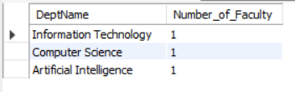

2. Display each faculty member and the number of interns under them
SELECT F.FacName,
COUNT(I.InternID) AS Number_of_Interns
FROM FACULTY F
LEFT JOIN INTERN I
ON F.FacNo = I.FacNo
GROUP BY F.FacName;
OUTPUT:
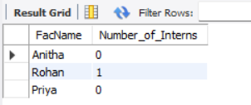

HAVING CLAUSE
3. Display faculty members having at least one intern (HAVING)
SELECT F.FacName,
COUNT(I.InternID) AS Number_of_Interns
FROM FACULTY F
JOIN INTERN I
ON F.FacNo = I.FacNo
GROUP BY F.FacName
HAVING COUNT(I.InternID) >= 1;
OUTPUT:


ORDER BY CLAUSE
4. Display faculty details from oldest to youngest
SELECT *
FROM FACULTY
ORDER BY Age DESC;
OUTPUT:
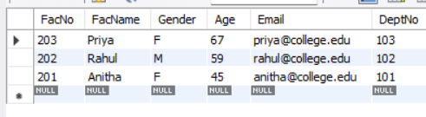

5. Display projects in ascending order of project name
SELECT *
FROM PROJECT
ORDER BY ProjectName ASC;
OUTPUT:
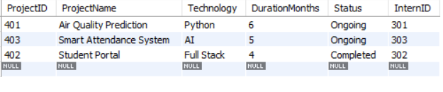

RESULT:

The GROUP BY, HAVING, and ORDER BY clauses were successfully executed to group, filter, and sort records from the tables.

